Linux session-2

mkdir – making directory
touch filename – create a file
cat filename – to view the file
cat filename .txt - to view the text in the file
d rwx – directory
-rwx – file
Chmod – change modification (changing the permissions for owner, groups, other)
R – Read 4
W - write 2
X – execute 1
Chown root:root filename (root-> username)
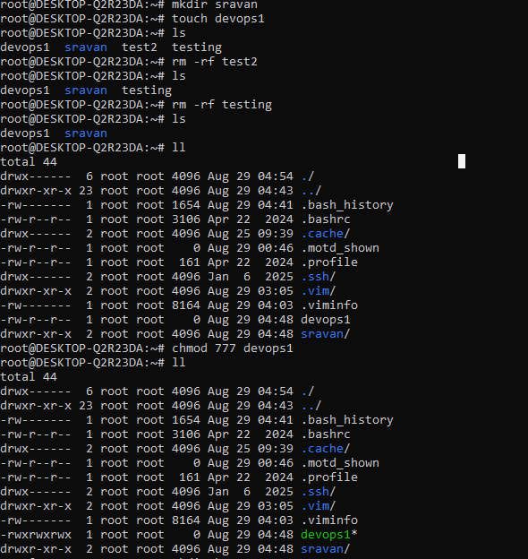
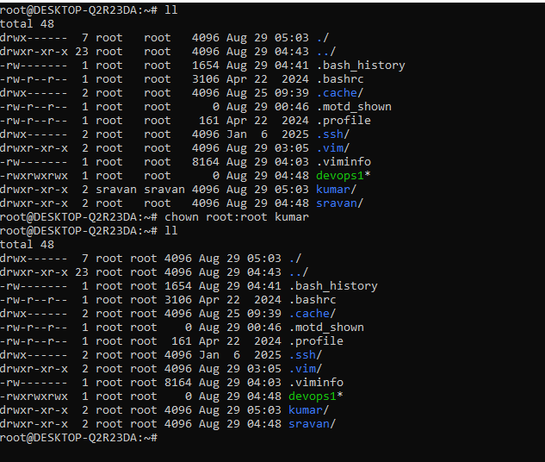

cat /etc/passwd - To check the list of users
useradd filename - To create user
passwd username - To create the password
su username - to switch user

find / -name filename - to check all the files
find –name filename - to check only one file

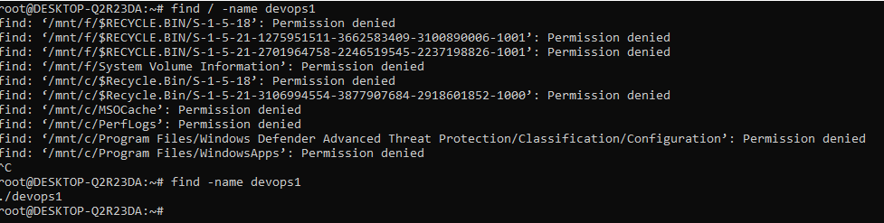

I/O redirections
echo “hello world”
echo “hello world” > test1 single redirection can override existing file or rename
echo “devops” >> test1 double redirection It combines the files

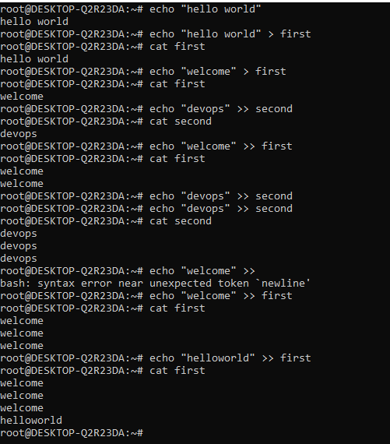

head -3 filename - show first 3 lines
tail -2 filname - show last 2 lines
tail -f filename - continosully moniter the file
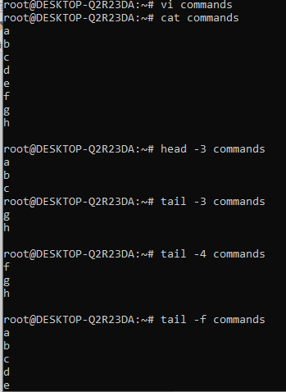

find / -name *.text - to find files with .txt extension ( * represents all )
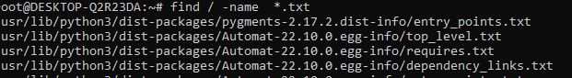

find / -name filename -mtime +30 - shows a file olderthan 30 days
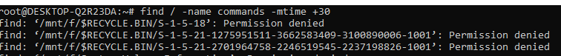

grep key filename - to find particular keyword
grep -I key filename - finding a keyword either capital or small word
